There are _________ types of cellular respiration
A. 2
B. 3
C. 4
D. 5
ANSWER: A
_______________is the process of producing cellular energy involving oxygen.
A. Digestion
B. Aerobic Respiration
C. Anaerobic Respiration
D. None of these
ANSWER: B

In _____________, glucose breaks down without oxygen.
A. Anaerobic Respiration
B. Aerobic Respiration
C. Digestion
D. None of these
ANSWER: A

In____________, Glucose a six carbon molecule is degraded through sequential enzyme dependent reactions into two molecules of pyruvic acid, a three carbon compound.
A. Glycolysis
B. Respiratory chain
C. Phosphorylation
D. None of these
ANSWER: A

The ______________in glycolysis is the transfer of phosphate group from ATP to No.6 carbon of glucose.
A. First step
B. Last step
C. Middle step
D. None of these
ANSWER: A
The type of fermentation in which the two molecules of pyruvic acid are reduced to two molecules of ethanol and $2CO_{2}$ is called:
A. Acidic fermentation
B. Aerobic Respiration
C. Alcoholic fermentation
D. Photosynthesis
ANSWER: C
When glucose breaks down into a substance called lactic acid, then it is called:
A. Acidic fermentation
B. Aerobic Respiration
C. Alcoholic fermentation
D. Photosynthesis
ANSWER: A
Alcoholic fermentation occur in:
A. Bacteria
B. Yeast
C. Fungi
D. All of these
ANSWER: D
Lactic acid fermentation occurs in:
A. Animals
B. Skeletal muscles of humans
C. Bacteria present in milk
D. All of these
ANSWER: D
In an oxidation process 14135KJ energy is release, how many moles of glucose consume during this process
A. 1
B. 3
C. 5
D. 10
ANSWER: C
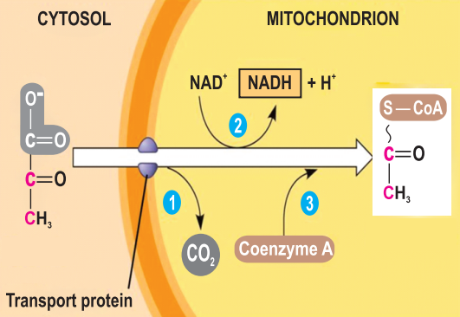
Which of the following is formed in cytosol?
A. Acetyl CoA
B. Pyruvate
C. Both A and B
D. None of these
ANSWER: B

Which of the following is formed in the mitochondria?
A. Acetyl CoA
B. Pyruvate
C. Both A and B
D. None of these
ANSWER: A
The oxidation of pyruvate takes place in ______steps
A. 5
B. 2
C. 3
D. 6
ANSWER: C
___________in which a molecule of CO2 is removed from pyruvate to form acetaldehyde
A. Isomerization
B. Decarboxylation
C. Phosphorylation
D. Splitting
ANSWER: B
Conversion of pyruvate to Acetyl CoA, the junction between _________and the citric acid cycle
A. Glycolysis
B. Krebs’s cycle
C. ETC
D. Calvin cycle
ANSWER: A

